[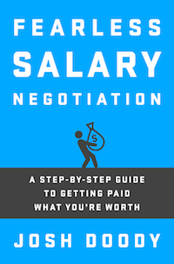](http://FearlessSalaryNegotiation.com/?utm_medium=ebook&utm_source=fearless+salary+negotiation&utm_campaign=extras&utm_content=how+to+leave+a+job+on+the+best+possible+terms+chapter)***Fearless Salary Negotiation:***

***A step-by-step guide to getting paid what you’re worth***

**Companion materials for “Chapter 5. How to leave a job on the best possible terms”**

**Learn more and get the book at** [**FearlessSalaryNegotiation.com**](http://FearlessSalaryNegotiation.com/?utm_medium=ebook&utm_source=fearless+salary+negotiation&utm_campaign=extras&utm_content=how+to+leave+a+job+on+the+best+possible+terms+chapter)

**Sample email to send your colleagues when you’re leaving a job. (See next page)**

**Reach out to your colleagues to say goodbye and share your contact information**

**An example of an email you can send your colleagues when leaving your job. This is a way to say goodbye and to keep in touch while leaving on the best possible terms.**

**To:** ACME Corp—Consulting Practice  
**CC:** Josh Doody <josh@example.com> [personal email address]

**Subject:** See you around!

Hi everyone

Today is my last day working with this amazing team at this amazing company. It has been a pleasure working with all of you, and I'm grateful for the opportunity to work with such a great team of experts. The amount of talent in this group is really astounding.

I've been in this industry for almost 10 years now, and I've learned that this is a very tight-knit industry where I continuously bump into old friends. I'm sure we'll cross paths again, and that's very comforting given how great this team is.

If you ever need anything or have any questions for me about any of my projects or responsibilities please reach out and ask. Don't spin your wheels trying to figure something out when you could just email me for a quick answer!

And of course, please stay in touch and feel free to reach out at any time to say hello.

My personal email address is: josh@example.com

I'm on LinkedIn at: https://www.linkedin.com/in/joshdoody

Thank you for this tremendous opportunity, and for making this such a fantastic place to work!

All the best

Josh